AI Assistant lab -19.3
Name:A.YASHWANTH
Batch:42
Rollno:2303A52432
Task 1 – Python to C++ Conversion Task:
Translate a simple Python class into C++ using AI assistance.
Instructions:
- Prompt AI to convert a Python class representing a Student with attributes and methods into equivalent C++ code
- Ensure proper handling of:
class Student:
def init (self, name, age):
self.name = name self.age = age
def display(self):
print(self.name, self.age)

s = Student("John", 20) s.display()
#include <iostream> using namespace std;
class Student { private:
o Constructors o Data types o Access specifiers
• Compile and run both versions to verify output consistency
Prompt
Convert a Python class Student with attributes name, age and a display() method into equivalent C++ code with constructor and proper access specifiers. Python code
C++ code
Output:
Justification

string name; int age;
public:
Student(string n, int a) { name = n; age = a;
}
void display() { cout << name << " " << age << endl; }
};

int main() {
Student s("John", 20); s.display(); return 0;
}

Justification
Constructor added explicitly in C++
Data types defined (string, int)
Encapsulation via private/public
Output verified same in both languages Task 2 – Java to Python Function Conversion Task:
Convert a Java method that checks whether a number is prime into Python.
Instructions:
- Ask AI to translate a Java isPrime() method into Python
- Test the function with multiple inputs
- Ensure the Python version follows Pythonic syntax and logic Prompt:
def is_prime(n):
if n <= 1:
return False
for i in range(2, n//2 + 1):
if n % i == 0:
return False
return True
print(is_prime(7)) print(is_prime(10))
public static boolean isPrime(int n) { if(n <= 1) return false; for(int i=2; i<=n/2; i++) { if(n % i == 0) return false;
} return true;
}
Convert Java method isPrime(int n) into Python function using Pythonic syntax. Java code
Python code
Output:

Justification
Python uses indentation instead of braces range() replaces loop structure
Cleaner syntax (no type declaration)
Logic preserved exactly
Task 3 – Pseudocode to Python Implementation Task:
Translate a given pseudocode algorithm into Python using AI.
Instructions:
def bubble_sort(arr): n = len(arr) for i in range(n):
for j in range(0, n-i-1):
if arr[j] > arr[j+1]:
arr[j], arr[j+1] = arr[j+1], arr[j]
return arr
data = [5, 2, 9, 1] print(bubble_sort(data))
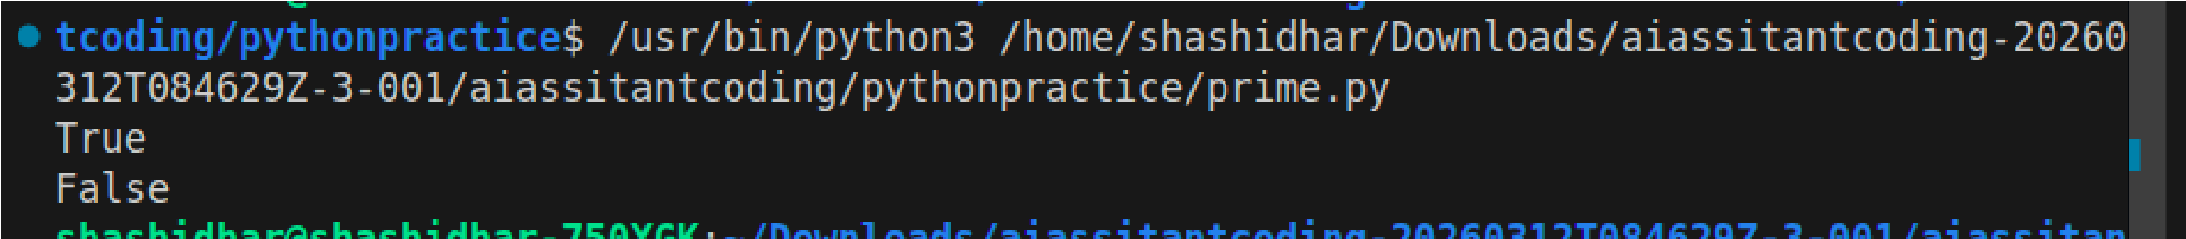
- Provide AI with pseudocode for sorting numbers (e.g., bubble sort or selection sort)
- Ask AI to convert it into executable Python code
- Validate correctness using sample input lists
Prompt
Convert bubble sort pseudocode into Python program.
Code
Output:

Justification:
Pseudocode loops directly mapped to Python loops
Swap done using tuple unpacking
Algorithm correctness verified Task 4 – SQL to Pandas Query Task:
Translate a SQL query into a Pandas DataFrame operation in Python.
import pandas as pd
data = {
"name": ["A", "B", "C"],
"salary": [40000, 60000, 70000]
}
Instructions:
- Provide AI with a SQL query (e.g., SELECT name, salary FROM employees WHERE salary > 50000).
- Ask AI to generate equivalent Pandas code.
- Test the generated code on a sample DataFrame Prompt:
Convert SQL query SELECT name, salary FROM employees WHERE salary > 50000 into Pandas code.
Code
Sql query
ELECT name, salary FROM employees WHERE salary > 50000;
Python pandas code

df = pd.DataFrame(data)

result = df[df["salary"] > 50000][["name", "salary"]] print(result)
Output:

Justification
WHERE → Boolean filtering
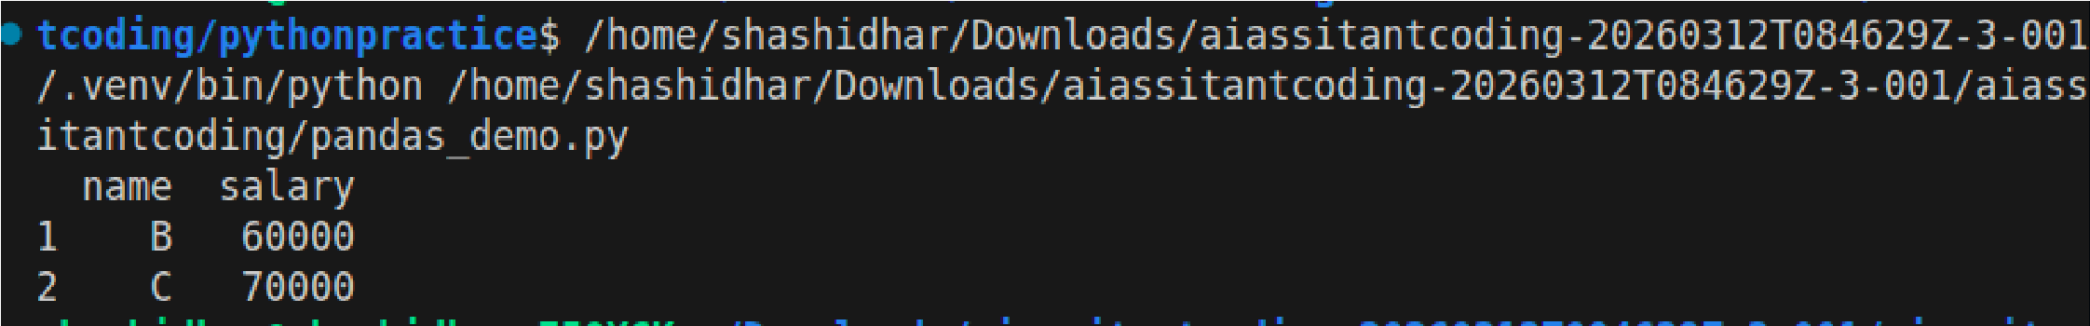
SELECT → column selection
Equivalent data subset returned
Task 5 – Real-Time Application: Algorithm Translation Across
Languages
Scenario:
A company maintains algorithms written in different programming languages.
Examples:
- Converting a Python searching algorithm into C • Translating a Java sorting program into JavaScript
Instructions:
- Use AI to translate a selected algorithm between two programming languages
- Execute and test both versions
- Document translation challenges such as: o Syntax differences o Library support o Memory management
Prompt
def search(arr, key):
for i in range(len(arr)):
if arr[i] == key:
return i
return -1

print(search([1,2,3,4], 3))
Convert Python linear search algorithm into C language with proper memory handling.
Code

C code

#include <stdio.h>
Output:

int search(int arr[], int n, int key) { for(int i = 0; i < n; i++) { if(arr[i] == key) return i;
}
return -1;

}

int main() {
int arr[] = {1,2,3,4};
int result = search(arr, 4, 3); printf("%d\n", result);
return 0;

}

Justification
Manual array handling in C
No dynamic typing → explicit sizes required Memory handled via static arrays
Same logic preserved

